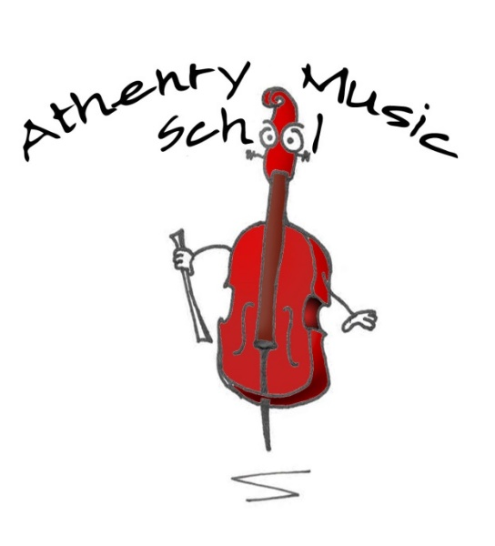

CONCERT SCHEDULE 2020-21

In the current climate, events may be hosted on zoom or online video releases

17 Sept (Thurs) 5pm-6pm AYC Open Air rehearsal with Ruth Smith
(Make a joyful noise Athenry2020)
18 Sept (Fri) Time TBC Athenry Arts Festival : violin soloists in the Heritage centre
(Outside)
3 Oct (Sat) Make a joyful noise – Athenry 2020- Athenry Youth Choir
22 Nov (Sun) Suzuki Graduation Concert- ZOOM Community Hall booking sent
13th -22nd Dec ) 9 days A union of Voices – ONLINE 9 writers plus 9 orchestras and choirs

31 January (Sun) Piano Festival Day and Senior Violins - ZOOM
28 Feb (Sun) Guitar Festival Day- De Burgo – booked
7 Mar (Sun) SPRING into Music CONCERT with Coole Music
Junior guitar orchestra, Cor Le Kids, Creation Orchestra
Tbc Three Rings Arts Festival, Tuam Cor Le Cheile Athenry Youth Choir String quartets Horizon orchestra Sligo Academy
28 Mar (Sun) AYO /AYC Contempo Minnetonka High School Choir Raheen Woods
18-28 March 2021 Cellissimo
4th April Easter
18th Apr (Sun) MEGA Concert – LIVE or ONLINE of each orchestra
23rd May (Sun) Galway Early Music Horizon orchestra & Guitar Orchestras
The Gregory Walkers Sunday 2.30pm workshop and 5pm concert
24th – 28th May SOLO CONCERT WEEK Bistro Booked
3 June Creation Orchestra Tour to Dublin Ballinteer Educate together Notre Dame Building Churchtown
10-12th June 2021 Paper Boat

